BOOK INFORMATION TABLE

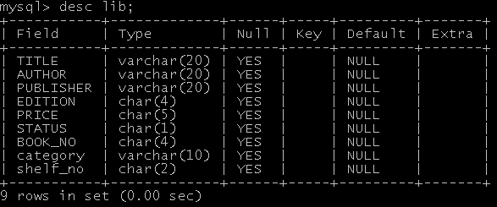

MEMBER TABLE

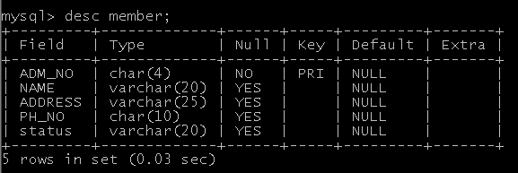

PUBLISHER TABLE

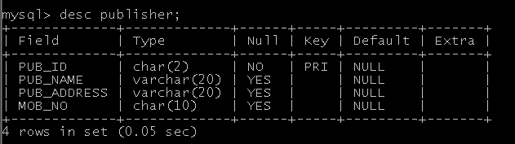

CATEGORY TABLE

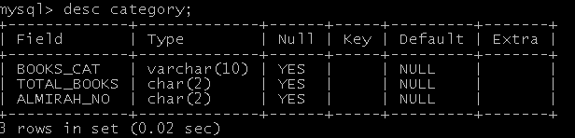

MASTER ISSUE TABLE

